**Project Design Phase**

**Solution Architecture**

|  |  |
| --- | --- |
| Date | 27 June 2025 |
| Team ID | LTVIP2025TMID59193 |
| Project Name | SmartSDLC – AI-Enhanced Software Development Lifecycle |
| Maximum Marks | 4 Marks |

**Solution Architecture:**

Solution Architecture is a detailed, structured framework that defines how a system or application will meet specific business requirements through a combination of technology, design, and implementation strategies.

* In the SmartSDLC – AI Enhanced Software Development Lifecycle Project, the solution architecture defines how various AI-powered modules—such as the Requirement Classifier, Bug Fixer, and Code Generator—work together within a streamlined platform.
* This architecture also manages data flow, user interaction, and performance, ensuring the system is scalable, secure, and user-friendly. By aligning technical components with user needs, it helps deliver a cohesive, intelligent solution for automating the SDLC process.

**Example - Solution Architecture Diagram:**

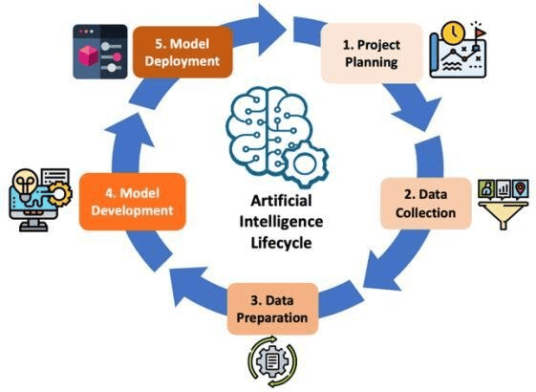

Reference <https://www.researchgate.net/publication/378545816/figure/fig1/AS:11431281226334350@1709133251576/AI-Development-Life-Cycle.jpg>